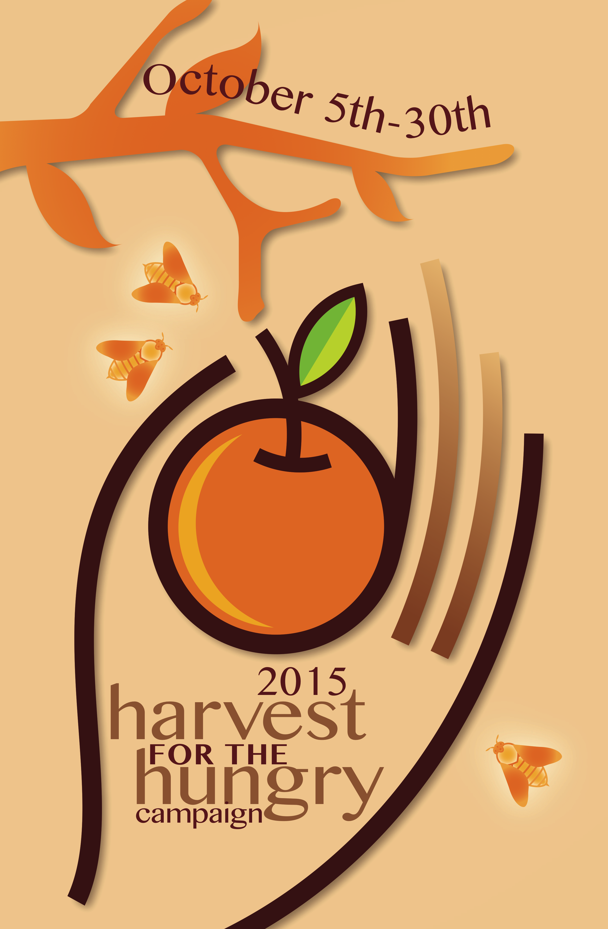 | Thank You!  for your generous support of the Anne Arundel County Food & Resource Bank. Contributions of funds, food and household goods are welcomed all year long.  www.aafoodbank.org

Family Involvement Conference
Click here for more information.

Volunteer of the Month
October 2015
Lisa Collins
Jacobsville Elementary School
For graciously dedicating her time and talents to engaging volunteers, fundraising, organizing events and much more.

To nominate outstanding volunteers for the AACPS Volunteer of the Month Award, email ttudor@aacps.org

Office of School & Family Partnerships AACPS TV Programs: Comcast and Broadstripe Channel 96,
& Verizon Channel 36.
Parent Connection, Parents’ Corner, World View
Nuestra Comunidad (Our Community), and
¡Charlemos Juntos! (Let’s Chat)

Family Involvement Conference
ENGAGE, EMPOWER, EDUCATE

Saturday, November 14, 2015
8:30 am – 2:30 pm
Anne Arundel Community College
101 College Parkway, Arnold, MD

For Parents of Children Ages 4 - 17
13 Workshops over 3 Breakout Sessions

Just a Sampling of the 13 Workshop Choices:

Using a Growth Mindset to Cultivate Your Child’s Potential
Join us to learn how using growth mindset strategies will empower your child to set and achieve goals, persevere, and achieve his fullest potential.

The Power of Parent Involvement in Special Education
We will focus on ways for parents to feel more comfortable as equal participants in their child’s IEP team meetings. We will demystify the complexities of special education and the IEP process.

“BIG” Ideas to Grow Readers
(separate breakouts for parents of elementary and middle/high students)
Participants will gain ideas, knowledge, and activities to use at home to support children’s reading. Expect engaging hands-on activities.

ADHD: Behavior Modification Through the Day
We will discuss principles of behavior modification and specific strategies for managing challenging behaviors.

Common Core Math... Not so Common at Home!
The Common Core State Standards (CCSS) are meant to teach students to think in different ways and use multiple strategies to solve real-world problems. What can parents do to help with homework? You will leave with a take-home packet of resources including games, websites, and video links, to increase and encourage flexible thinking about numbers.

Conference is Free | Continental Breakfast & Lunch Provided

Please Register Early at www.aacps.org/conference.

Languages: Spanish interpreters present; for interpretation in other languages: 410-222-5417. Three workshops presented in Spanish.

Limited child care: Pre-registration required at 410-222-5309; ages 3–12 only; children under age16 may not attend workshops, (AACC rules).

November 2015
The evidence is consistent, positive, and convincing: families have a major influence on their children’s achievement. When schools, families, and community groups work together to support learning, children tend to do better in school, stay in school longer, and like school more.” Anne T. Henderson, Karen L. Mapp

A Bi-Monthly Publication by:

The Office of School & Family Partnerships

410-222-5414; ttudor@aacps.org

Parent Link

Parent Link
Connecting You and Your Child to Information on Our Journey to Great
ness






