
ENGAGE, EMPOWER, EDUCATE:


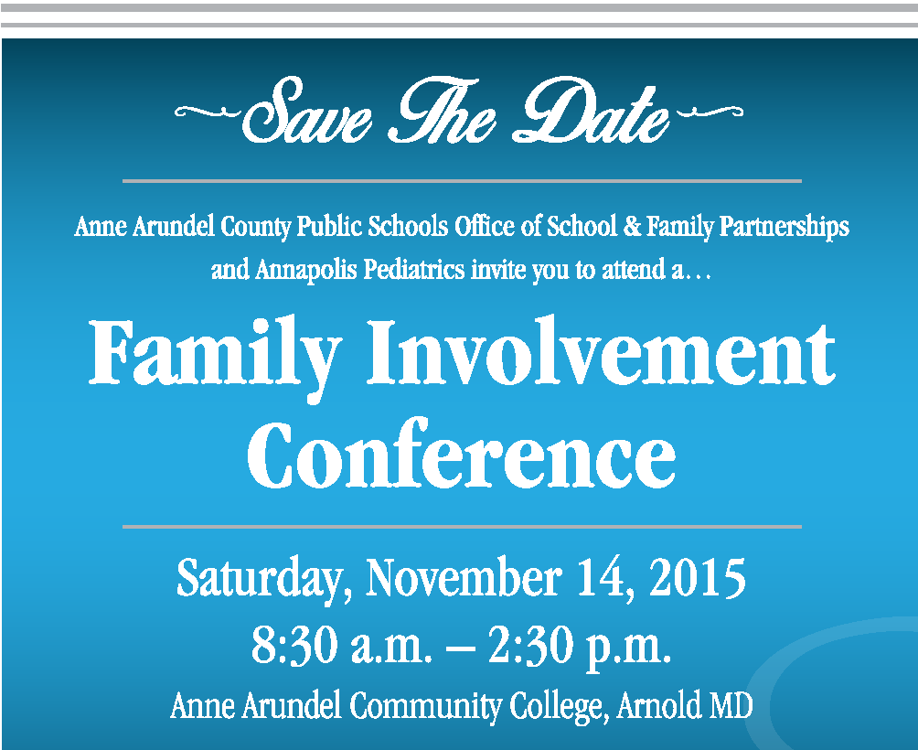

Office of School & Family Partnerships AACPS TV Programs on Channels: Comcast 96, 996 HD; Broadstripe 96, 496 HD,
& Verizon 36.
Parent Connection, Parents’ Corner, World View
Nuestra Comunidad (Our Community), and
¡Charlemos Juntos! (Let’s Chat)

A Bi-Monthly Publication by:

The Office of School & Family Partnerships

410-222-5414; ttudor@aacps.org
The evidence is consistent, positive, and convincing: families have a major influence on their children’s achievement. When schools, families, and community groups work together to support learning, children tend to do better in school, stay in school longer, and like school more.” Anne T. Henderson, Karen L. Mapp

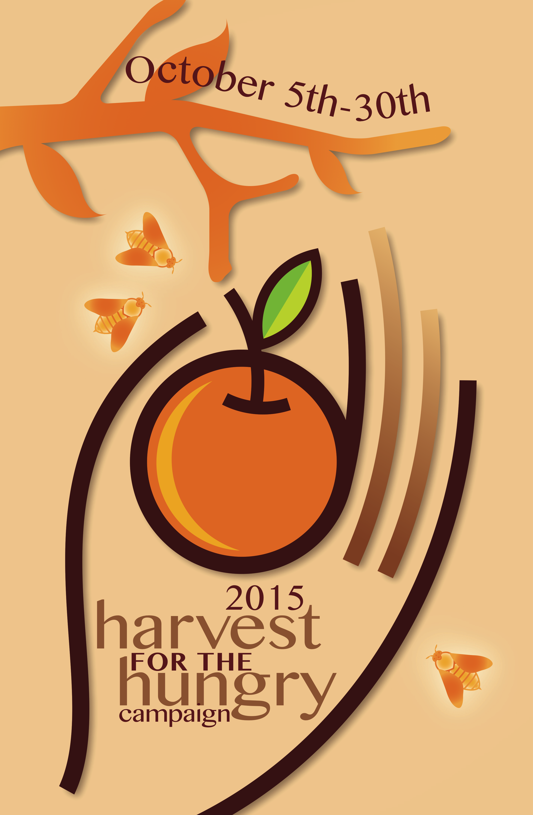 | It’s Harvest Time!!  Donations  Accepted  October  5th – 30th

Poverty is affecting over 28,000 people
in Ann Arundel County, one third are children.

Watch for your school’s
Harvest for the Hungry Campaign
collection of canned foods & cash.

Each $1 donated purchases 8 pounds of food.

Donate online: www.MyPaymentsPlus.com
or https://21st-education.org/
or by check to
AAC Food Bank, memo: “Harvest for the Hungry.”

Volunteer of the Month
September 2015
Mrs. Kelsa McLaughlin
Hillsmere Elementary
For dedicating her time and talents to raise technology funds and for superbly managing the “Hillsmere Publishing Company.”

To nominate outstanding volunteers for the AACPS Volunteer of the Month Award, email TTudor@aacps.org

Parent Link

Parent Link
Connecting You and Your Child to Information on Our Journey to Greatness

October 2015





