Ms. Bittman Mrs. Zeytinoglu
rbittman@aacps.org szeytinoglu@aacps.org

Welcome to AP Lit! We are glad you have chosen to accept the challenge of AP Lit and we look forward to seeing you in the fall. This summer you will be reading How to Read Literature Like a Professor (revised edition) this text will lay the foundation for your success in AP Literature. With that in mind please remember that we are looking for your original thoughts on the assignments. Do not use internet sources to look for answers to the assignments; all you need is the text and your own brainpower. You will have some flexibility and choice in how to apply the following assignments, but you should have them finished when you return to school in August because we will plan based on the assumption they are finished. See the last page of this packet for final comments and a checklist.

- Read the entire text of Thomas C. Foster’s How to Read Literature Like a Professor
- Complete the accompanying assignments.

If you have “extra” time this summer and wish to exercise your brain or work ahead, check out some of the following books. The list below contains the most frequently cited texts on the AP Lit Exam from 1970 to 2012. Many of these are texts that were assigned in previous English classes; those marked with an asterisk are texts we may be reading in class, either together or as part of a literature circle.

This list is here as a resource; the only assigned reading is How to Read Literature Like a Professor.

25 Invisible Man by Ralph Ellison*  20 Wuthering Heights by Emily Bronte*  17 Great Expectations by Charles Dickens*  16 Crime and Punishment by Fyodor Dostoevski  16 Heart of Darkness by Joseph Conrad*  16 King Lear by William Shakespeare  15 Jane Eyre by Charlotte Bronte*  15 Moby Dick by Herman Melville  14 The Adventures of Huckleberry Finn by Mark Twain  12 Catch-22 by Joseph Heller  12 The Great Gatsby by F. Scott Fitzgerald  12 Portrait of the Artist as a Young Man by James Joyce  12 The Scarlet Letter by Nathaniel Hawthorne  11 The Awakening by Kate Chopin*  11 Billy Budd by Herman Melville  11 Ceremony by Leslie Marmon Silko  11 Light in August by William Faulkner  11 Their Eyes Were Watching God by Zorah Neale Hurston*  10 As I Lay Dying by William Faulkner  10 The Glass Menagerie by Tennessee Williams  10 Native Son by Richard Wright  9 Antigone by Sophocles  9 Beloved by Toni Morrison*  9 The Color Purple by Alice Walker  9 Othello by William Shakespeare  9 A Passage to India by E. M. Forster  9 Song of Solomon by Toni Morrison  9 A Streetcar Named Desire by Tennessee Williams*  8 Anna Karenina by Leo Tolstoy  8 Bless Me, Ultima by Rudolfo Anaya  8 Candide by Voltaire  8 Death of a Salesman by Arthur Miller  8 Jude the Obscure by Thomas Hardy  8 The Jungle by Upton Sinclair  8 A Raisin in the Sun by Lorraine Hansberry  8 Rosencrantz and Guildenstern Are Dead by Tom Stoppard  8 Sula by Toni Morrison  8 Waiting for Godot by Samuel Beckett  7 All the King’s Men by Robert Penn Warren  7 All the Pretty Horses by Cormac McCarthy | 7 The Crucible by Arthur Miller  7 Cry, The Beloved Country by Alan Paton  7 The Grapes of Wrath by John Steinbeck  7 Lord Jim by Joseph Conrad  7 Madame Bovary by Gustave Flaubert  7 The Mayor of Casterbridge by Thomas Hardy  7 Oedipus Rex by Sophocles *  7 Portrait of a Lady by Henry James  7 Pride and Prejudice by Jane Austen*  7 The Sun Also Rises by Ernest Hemingway  7 The Tempest by William Shakespeare  6 A Doll’s House by Henrik Ibsen  6 An Enemy of the People by Henrik Ibsen  6 Equus by Peter Shaffer  6 Ethan Frome by Edith Wharton*  6 Gulliver’s Travels by Jonathan Swift  6 Hedda Gabler by Henrik Ibsen  6 Major Barbara by George Bernard Shaw  6 Medea by Euripides  6 The Merchant of Venice by William Shakespeare 6 Moll Flanders by Daniel Defoe  6 Mrs. Dalloway by Virginia Woolf  6 Murder in the Cathedral by T. S. Eliot  6 Obasan by Joy Kogawa  6 The Piano Lesson by August Wilson  6 The Sound and the Fury by William Faulkner  6 Tess of the D’Urbervilles by Thomas Hardy  6 Things Fall Apart by Chinua Achebe  6 The Turn of the Screw by Henry James  6 Who’s Afraid of Virginia Woolf? by Edward Albee  5 Age of Innocence by Edith Wharton  5 Bleak House by Charles Dickens  5 The Cherry Orchard by Anton Chkhov  5 Doctor Faustus by Christopher Marlowe  5 Frankenstein by Mary Shelley  5 Go Tell It on the Mountain by James Baldwin  5 Hamlet by William Shakespeare*  5 Macbeth by William Shakespeare  5 Mrs. Warren’s Profession by George Bernard Shaw  5 Sister Carrie by Theodore Dreiser  5 Wide Sargasso Sea by Jean Rhys  5 Wise Blood by Flannery O’Connor
Assignment Outline:
How To Read Literature Like a Professor (revised edition) – Thomas C. Foster.

DIRECTIONS: This reading will to help you to understand the sort of things you should be looking for when reading texts for AP Literature.

- You are responsible for reading and understanding the entire text.
- There are 5 assignments to be completed for chapters of your choosing.
- Two of the assignments are for specific chapters.
- No chapter may be used for more than one assignment.

Quantity | Assignment Type | Where to find specific directions
3 chapters | One-pager | Directions on page 3
1 chapter | Dialectical Journal | Directions on page 4-5
Chapter 1 | Writing Prompt | Directions on page 6
Chapter 14 | Writing Prompt | Directions on page 6
1 chapter | Test | Directions on page 6

NOTE: Each of the assignments must be completed using a different chapter so that in the end you have interacted with as many of the chapters as possible. Remember that this work will lay the foundation for the course and you will be using this material throughout the year both in application to the texts and in essays.

I. AVID One-Pager – You will complete 3 of these for chapters of your choosing

DESCRIPTION: A One-pager is a written and graphic interpretation on a single sheet of paper of what you have just read. It may be literal or it may be a symbolic representation of the piece. The one-pager will help you visualize what you are reading and help prepare you for other activities that we may complete using this reading assignment.
PURPOSE: The purpose of a One-Pager is to own what you are reading. We think about what we see and read differently when we are asked to do something with what we have seen or read. We learn best when we create our own ideas. The One-pager will help you visualize what you are reading and help prepare you for other activities that we will complete related to this reading assignment.
CONNECTIONS: A One-Pager connects the verbal and visual. It connects the author’s, filmmaker’s, artist’s, or culture’s thoughts to your thoughts. It makes connections between words and images.

WHAT TO DO:
- Use standard (8.5 by 11) unlined paper
- Fill the entire page
- Written work must be in ink or typed (no pencils unless colored pencils)
- Use color as much as possible
- Include all of the following (arranged on the page any way you choose):
  - Title and Author
  - Three or more excerpts from the reading (passages you think are especially important include page numbers)
  - A response to each passage you select (analytical or interpretive)
  - Drawings or pictures the symbolize or characterize elements of the text
- Add a border or any other decorations and you’re done!
- Be prepared to give an oral “tour” of your One-pager
*DO NOT USE LINED PAPER,
MERELY SUMMARIZE, OR FAIL TO USE ALL OF THE SPACE ON THE PAPER. Doing so will result in a lower grade.
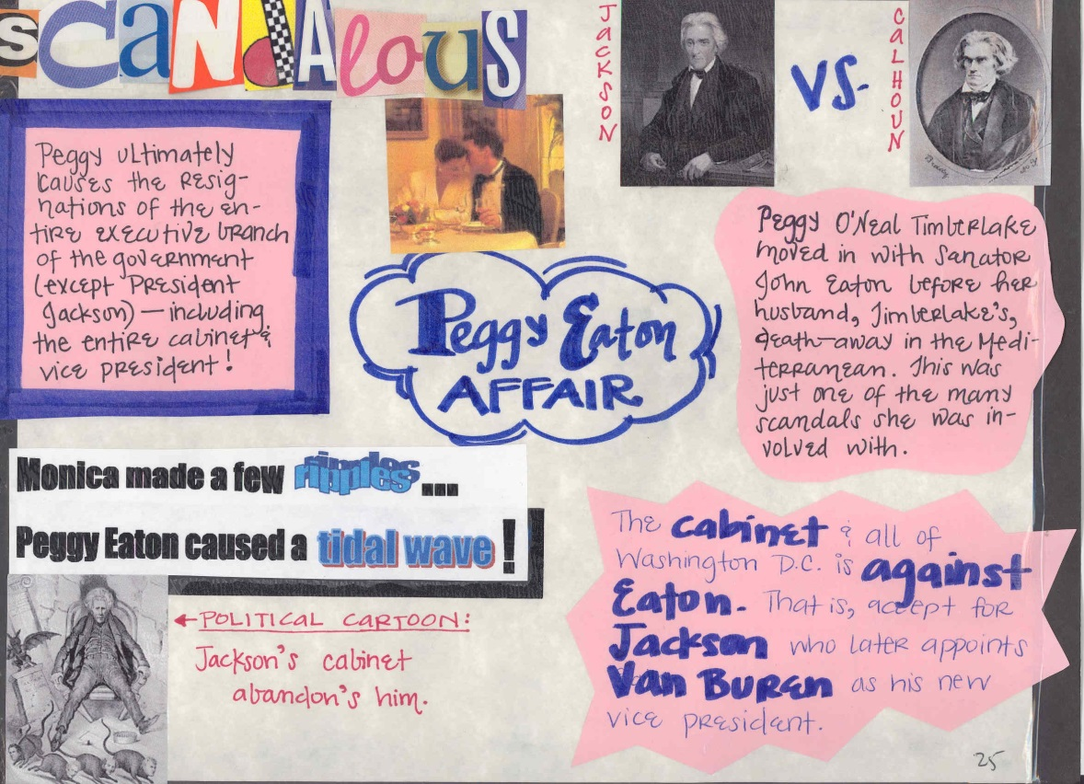
II. Dialectical Journals – You will complete 1 of these for a chapter of your choosing

Directions: Please type this journal using the same format shown here. Simply insert a two column table. You will choose 5 passages to respond to in the chapter. Each of your responses should be a minimum of 75-100 words.
The term “Dialectic” means “the art or practice of arriving at the truth by using conversation involving question and answer.” Think of your dialectical journal as a series of conversations with the texts we read during this course. The process is meant to help you develop a better understanding of the texts we read. Use your journal to incorporate your personal responses to the texts, your ideas about the themes we cover and our class discussions. You will find that it is a useful way to process what you’re reading, prepare yourself for group discussion, and gather textual evidence for your Literary Analysis assignments.
Procedure:
- As you read, choose 5 passages that stand out to you and record them in the left-hand column of a T-chart (ALWAYS include page numbers).
- In the right column, write your response to the text (ideas/insights, questions, reflections, and comments on each passage)
- Label your responses using the following codes:
  - (Q) Question – ask about something in the passage that is unclear
  - (C) Connect – make a connection to your life, the world, or another text
  - (P) Predict – anticipate what will occur based on what’s in the passage
  - (CL) Clarify – answer earlier questions or confirm/disaffirm a prediction
  - (R) Reflect – think deeply about what the passage means in a broad sense – not just to the characters in the story. What conclusions can you draw about the world, about human nature, or just the way things work?
  - (E) Evaluate - make a judgment about the character(s), their actions, or what the author is trying to say

Sample Dialectical Journal entry: THE THINGS THEY CARRIED by Tim O’Brien

Passages from the text | Comments & Questions
“-they carried like freight trains; they carried it on their backs and shoulders-and for all the ambiguities of Vietnam, all the mysteries and unknowns, there was at least the single abiding certainty that they would never be at a loss for things to carry”(2).  *the ‘(2)’ above is the page number | (R) O’Brien chooses to end the first section of the novel with this sentence. He provides excellent visual details of what each solider in Vietnam would carry for day-to-day fighting. He makes you feel the physical weight of what soldiers have to carry for simple survival. When you combine the emotional weight of loved ones at home, the fear of death, and the responsibility for the men you fight with, with this physical weight, you start to understand what soldiers in Vietnam dealt with every day. This quote sums up the confusion that the men felt about the reasons they were fighting the war, and how they clung to the only certainty - things they had to carry - in a confusing world where normal rules were suspended.

Choosing Passages from the Text:
Look for quotes that seem significant, powerful, thought provoking or puzzling. For example, you might record:

- Effective and/or creative use of stylistic or literary devices
- Passages that remind you of your own life or something you’ve seen before
- Structural shifts or turns in the plot
- A passage that makes you realize something you hadn’t seen before
- Examples of patterns: recurring images, ideas, colors, symbols or motifs.
- Passages with confusing language or unfamiliar vocabulary
- Events you find surprising or confusing
- Passages that illustrate a particular character or setting

Responding To the Text:
You can respond to the text in a variety of ways. The most important thing to remember is that your observations should be specific and detailed. The dialectical journal is a written conversation between you and the book—make sure you hold up your end! Remember that this journal must demonstrate that you have carefully read and understood this book. DO NOT simply summarize; you must analyze and evaluate.

Basic Responses
  - Raise questions about the beliefs and values implied in the text
  - Give your personal reactions to the passage
  - Discuss the words, ideas, or actions of the author or character(s)
  - Tell what it reminds you of from your own experiences
  - Write about what it makes you think or feel
  - Agree or disagree with a character or the author

Sample Sentence Starters:
I really don’t understand this because…
I really dislike/like this idea because…
I think the author is trying to say that…
This passage reminds me of a time in my life when…
If I were (name of character) at this point I would…
This part doesn’t make sense because…
This character reminds me of (name of person) because…

Higher Level Responses
  - Analyze the text for use of literary devices (tone, structure, style, imagery)
  - Make connections between different characters or events in the text
  - Make connections to a different text (or film, song, etc…)
  - Discuss the words, ideas, or actions of the author or character(s)
  - Consider an event or description from the perspective of a different character
  - Analyze a passage and its relationship to the story as a whole

III. Application Responses – Directions: Complete each of the following prompts. Each prompt directs you to apply a chapter of How to Read Literature Like a Professor to a text – you must use a text you have previously read for a high school English class. If you just read the lists and not the whole chapter you won’t understand how these apply to other works.

Chapter 1 Prompt: Consider the five aspects of a QUEST and then apply them to something you read for a previous English class. Use the list on p. 4- 5 of How to Read Literature Like a Professor to structure your response. Be as specific as possible and try to avoid summarizing the text.

Chapter 14 Prompt: Apply the criteria on page 126 of How to Read Literature Like a Professor to a major character in a significant literary work. Try to choose a character that will have many matches. *You have to read the whole chapter to see how these apply. This is also a particularly apt tool for analyzing film – for example, Star Wars, Cool Hand Luke, Excalibur, Malcolm X, Braveheart, Spartacus, Gladiator and Ben-Hur..

IV. Student Created Test – You will complete 1 of these for a chapter of your choosing from How to read Literature Like a Professor.

Directions: You will create a multiple choice test with 10 questions, and 1 essay prompt. You must also provide an answer key.

- Test must be typed
- Each question should have 4 possible answers.
- Each question must include the page number on which the answer to the question may be found.
- The essay prompt should be clear and a higher level question not simple asking for a summary etc.
- The answer key should list the correct answer for each of the 10 questions and a 1 to 2 sentence outline of what a correct response to the essay prompt would be.

Model Question (Format): You can cut and paste this model into a Word/Google document in order to help with formatting your test.

- (page 29) In Chapter 4, Foster defines “intertextuality” as
  - the difference between texts
  - the communion of authors
  - the ongoing interaction between poems or stories
  - the reference to the bible that is common in western literature

IMPORTANT! READ THIS

Please make sure you followed the directions carefully.

Remember it’s more important to give thoughtful answers than to regurgitate someone else’s ideas.

Below is a checklist, complete this to keep track of your work.

If you have questions email both/either Ms. Bittman or Mrs. Zeytinoglu. We will respond as quickly as we can.

Summer Assignment Checklist

 | Item | Chapter/s used | Done
One-Pager
One-Pager
One-Pager
Dialectical Journal
Prompt 1 |  | 1
Prompt 2 |  | 14
Test

****TRUST US WHEN WE SAY, “DON’T WAIT UNTIL AUGUST TO START THIS!”****

