Summer Food Service Program
AACPS provides
Free Breakfast & Lunch
With summer right around the corner, it’s time to think about keeping children eating healthy foods while school is out.

For Children, ages 2-18
No registration; No income requirements

Eight specific locations throughout the county, plus a “Mobile Meals” truck.
Contact us for a site nearest you
or for other information.
Food4Thought@aacps.org
410-222-5900

Volunteer of the Month
May 2014
Carla DeWitt
Central Elementary School
… for her dedication to building and maintaining a strong school community that supports excellence in education
To nominate outstanding volunteers for the AACPS Volunteer of the Month Award, email ttudor@aacps.org

Office of School & Family Partnerships AACPS TV Programs: Comcast and Broadstripe Channel 96, & Verizon Channel 36.

Parent Connection, Parents’ Corner, World View, Nuestra Comunidad (Our Community), ¡Charlemos Juntos! (Let’s Chat)

Published by:

The Office of School & Family Partnerships

410-222-5414; ttudor@aacps.org

Summer Reading:
ESSENTIAL for EVERY Student’s Success

Did You Know?
- Children (Pre-K through 12th grade) who read during the summer, maintain and even grow their current reading skills and general knowledge levels.
- Those who do not read, lose about three months of reading and learning progress. They are most likely to fall behind their classmates.
Tips for Families
• Be a model for reading enjoyment. Let your children see you read and talk about what you’re reading.
• No matter how well your children read on their own, enjoy reading aloud together each day. “Share Read’ by alternating pages or chapters.
• Schedule trips to the library throughout the summer. Ask for booklists and suggestions. See Summer Library info below.
• Turn off the TV and video games for part of each day to read and to talk about the books or articles you are both reading.
• Encourage your child to read all types of materials: newspapers, information books, comics, picture books, chapter books, magazines, and poetry, rhymes and even riddles.
• Above all, enjoy the freedom of summer reading!

Check Out Your Library This Summer!

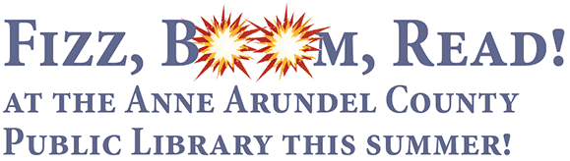 | 

Friday, June 27, Marley Station Mall in Glen Burnie!
Sneaks the Library Cat is bringing his good friends from Milkshake (of Nick JR and PBS KIDS fame) to Fizz, Boom, Read and ROCK with the Milkshake Duo, Lisa Mathews and Mikel Gehl in the mall’s center court!
Sign up for the Club while you’re there!

Club-related programs begin in all locations during the week of July 7 and run through August 8.

HAVE FUN!!
For booklists and more information: AACPS Elementary Reading
& Integrated Literacy Office at 410-222-5455

June 2014
“The evidence is consistent, positive, and convincing: families have a major influence on their children’s achievement. When schools, families, and community groups work together to support learning, children tend to do better in school, stay in school longer, and like school more.” Anne T. Henderson, Karen L. Mapp

Parent Link

Parent Link
Connecting You and Your Child to Information on Our Journey to Greatness






