“The evidence is consistent, positive, and convincing: families have a major influence on their children’s achievement. When schools, families, and community groups work together to support learning, children tend to do better in school, stay in school longer, and like school more.” Anne T. Henderson, Karen L. Mapp
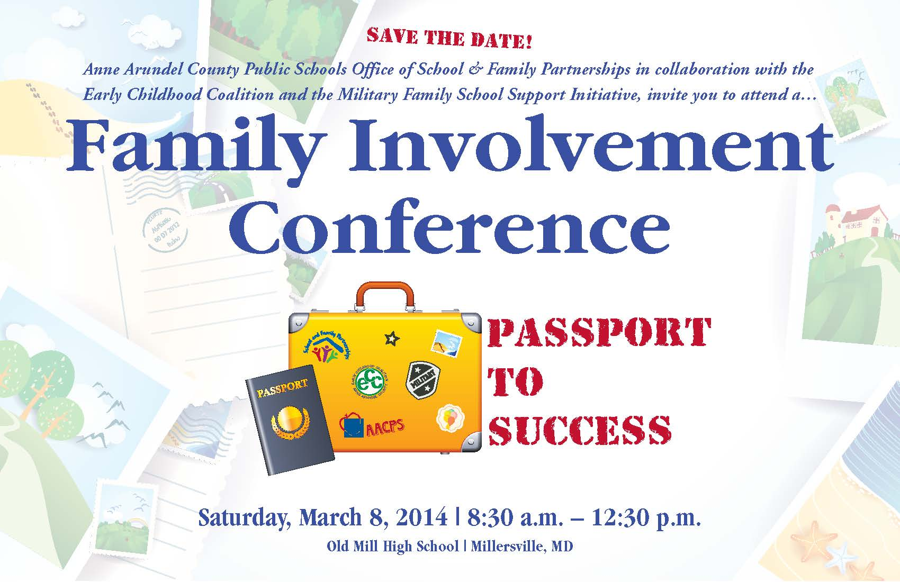
Saturday, March 8, 2014
8:30 a.m. – 12:30 p.m.
Old Mill High School, Millersville, MD

Join us for a dynamic keynote address by Shauna King, followed by a wide variety of workshops for families with children from birth through high school. Watch for registration information coming home with your child. www.aacps.org/family

Presented by
The Anne Arundel County Public Schools
Office of School & Family Partnerships with The Early Childhood Coalition and
The Military Family School Support Initiative

Volunteer of the Month
January 2014
Roxana Rodriguez
Annapolis Middle School
…for her commitment to encourage all families to be actively engaged in their children’s schools.

To nominate outstanding volunteers for the AACPS Volunteer of the Month Award, email ttudor@aacps.org

Office of School & Family Partnerships AACPS TV Programs on Comcast and Broadstripe Channel 96 & Verizon Channel 36:

Parent Connection, Parents’ Corner, World View
Nuestra Comunidad (Our Community), and
¡Charlemos Juntos! (Let’s Chat)

Plan to join us on Saturday, March 8th,
8:30 AM to 12:30 PM to learn about…. Watch our for conference and childcare registration information (our website).

Volunteer of the Month
January 2013
Roxana Rodriguez
Annapolis Middle School
for her commitment to encourage immigrant families to be actively engaged in their children’s schools.

To nominate outstanding volunteers for the AACPS Volunteer of the Month Award, email ttudor@aacps.org

Office of School & Family Partnerships AACPS TV Programs: Comcast and Broadstripe Channel 96,
& Verizon Channel 36.

Parent Connection, Parents’ Corner, World View
Nuestra Comunidad (Our Community), and
¡Charlemos Juntos! (Let’s Chat)

COMMON CORE CORNER: Math Homework
As parents, we’re naturally inclined to rush to rescue our children from struggling with homework when it becomes extra challenging. However, as our students learn to work through their initial discomfort (“I have no clue.”) to problem-solving confidence (“I can figure this out.”) math proficiency is gained. Learning to “make sense of problems and persevering to solve them” is Common Core Math Standard #1 for all grades.

Use the Teachers’ Strategies at Home:
Support the understanding that math problems are like puzzles and video games: they may require many tries, some mistakes, and some struggle to win. Give your child 1-3 minutes of quiet think time before discussion:
- Talk about what the problem is asking. What do you know about the problem? What are some problems like this one that you’ve solved before? What does the problem ask us to find out?
- Be a detective: look for clues and evidence for how to solve the problem.
- Use a variety of mathematical tools: items to count, a number line, draw pictures, act out the story, etc.
- Think about and try several ways to solve the problem. What might be another way to solve this problem?
- Reread the problem to make sure the problem is solved. Does your solution solve the problem? Explain the strategies you used and why. How is your graph connected to your equation? How does your equation match the problem?
- Congratulate your child for persevering to solve problems.

AACPS Summer Music Camp
for Band, Strings & Chorus Students at NorthBay Adventure Camp
When: July 27 – 31, 2014 Application Deadline: March 3, 2014 Overnight camp for AACPS music students entering grades 6-12. Focus: technique, musicianship, ensemble performance
Also: swimming, field games, zip lines, ropes courses, canoeing
Information: www.aacpsmusiccamps.org , 410-222-5465.

February 2014

Published by:

The Office of School & Family Partnerships

410-222-5414; ttudor@aacps.org

Parent Link

Parent Link
Connecting You and Your Child to Information on Our Journey to Greatness






