AP Summer Assignment: AP studio 3D Design

Due Date | 5th Class Meeting
Numbers of Sculptures to be completed | 4 or more.
Estimated time for completion | 10 weeks (throughout summer break)
Resources needed to complete assignments | - Art supplies; each project will describe what it needed. Each is low cost.  - Standard size sketch book  - Access to the internet for research portion
How the assignment will be assessed | Each piece will be assessed using the AP Art rubrics and the projects will count towards the total that must be completed for the quarter.  6 projects must be completed PER quarter.
Purpose of assignment | - Review of foundational material/concepts/skills  - Expose students to required material/concepts/skills/texts that cannot be covered during the academic year

Description:
This course is designed for the advanced art student who has demonstrated serious involvement in the visual arts and has shown a high degree of self-motivation. Ideally suited for students who work well independently, this course will prepare students who are considering a career or colligate placement within the visual arts.
Instructions: Your summer homework assignment has two parts; complete both parts and be prepared to submit them by the fourth class meeting, as well as participate in an oral critique about these experiences. Be advised that these summer assignments are worth a total of 600 points, which is equivalent to 20% of your first quarter grade so pace yourself to complete all of the work on time. This commitment to art making requires a time commitment of approximately 8+ hours per week for exploring personal areas of artistic investigation.

Part One: Sculptures
Complete 4 or more of the following sculptures. The aim in creating these sculptures is to build up your 3D portfolio and adding to the breadth portion of the AP 3D studio portfolio. There are multiple options employing found materials as well as those that may be purchase on your own. If available, you may collect some supplies from me upon request before summer break begins.
Few of the assignments have pictures associated with the project. Do not copy/recreated the images. They are there to help you get a visual of what is being asked.
•Multiples: Students will use A LOT (maybe 20 or maybe 300) of one type of common household object (ex: screws, toothpicks, etc.) to create a sculpture that emphasizes pattern and rhythm. Before starting, the objects may be painted if preferred.
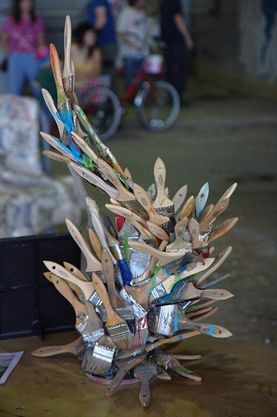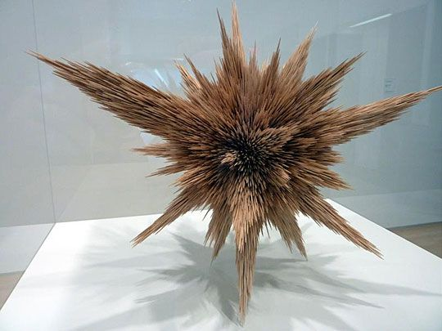
• Creating an Aesthetic Object from an Abandoned Derelict: Find an interesting object from the garage, attic, flea market, auction, or second-hand store. Transform the object by covering its entire surface with textural materials: mosaic, pebbles, glass, mirrors, feathers, flocking, yarn, paper, sand, photos, rope, coins, marble or granite chips, smaller objects, etc. Do this by using white glue: Spread glue on the surface, then sprinkle fine-particled materials such as sand, marble dust, or sawdust on it. (Use tile cement to attach heavier materials.) You can also use hot glue, wood glue, super glue or E6000 (this glue is very strong and has fumes. Use in a well ventilated area). You can find all this glue at Home Depot
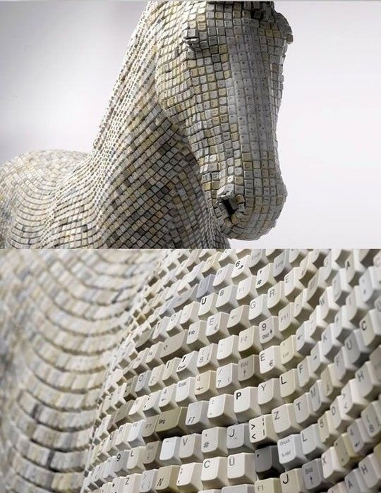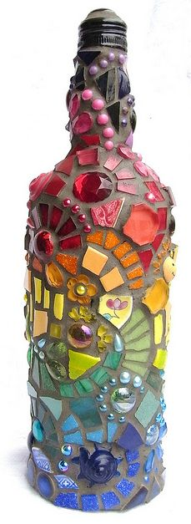
• Redoing an Old Masterwork: Select a sculpture or well-known image from art history for interpretation. Redo the work three-dimensionally: update it, change colors, media, characters; or, recreate a two-dimensional Old Master, three-dimensionally.
• 2D/3D Painting: Students will take their favorite 2D painting that they’ve done and transform it into a 3D piece. Any materials can be used to build up the depth within the piece, but it still must look fairly flat when viewing the piece head on.
Redoing and Old Masterwork and 2D/3D Painting are NOT the same project. For redoing, you are interpreting it in a different way. For the Painting you are recreating it in a 3D form.
• Natural Container: Using only natural materials (twigs, grasses, pods, stones, leaves) and twine or string, create a container for an object that has special meaning for you. The container must be at least 10 inches in one of its dimensions.
• Found object self-portrait: Using objects that have been gathered/found create a self-portrait with the objects.
• Altered Books: Students will acquire an old book from the library and make it into something new. All parts of the book can be ripped, cut, folded or altered in any other way in order to create a new story for the object.
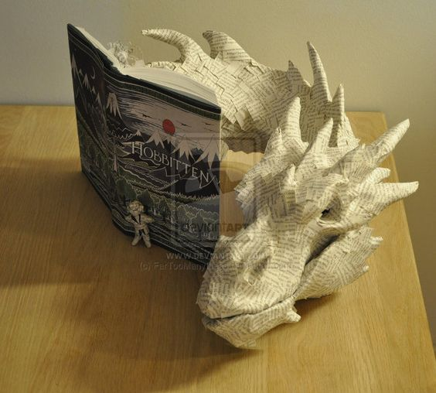

Part Two -Research Assignments:
Section1:
Students will research artists who create different types of three-dimensional artwork. Evidence of in-depth research (photos, articles, personal history, student thoughts, etc.) should be available in the student’s sketchbook for at least 5 different artists throughout history (20 points each).
Choose 5 of the artists listed below:
• Constantin Brancusi • Alexander Calder • Christo • Joseph Cornell • Donatello • Aristide Maillol • Henry Moore • Louise Nevelson • Claes Oldenburg • Pablo Picasso • Auguste Rodin
In your sketchbook set up 5 for the artist research. You should include facts about the artist that interest you. Cut and past images of the artist’s work into your sketchbook. I am not looking for a 1 page essay on the artist, I am look for an exploration of the artist and how you relate to their artwork. How do they inspire you? What makes it interesting to you? There should be information about that artist, but again how is this research helping you as a sculptor?
Section 2:
Visit the AP College Board website and look at prior studio art portfolios. http://apcentral.collegeboard.com and go to the AP Studio Art: 3-D Design Course Home Page.
Title a page in your sketchbook, AP COLLEGE BOARD REFLECTION. Go to the College Board website listed above. Write a one page reflection on your understanding of what is required of you as an AP Studio artist and what personal goals (3-5) have you set based on looking at other high school artist’s portfolios. This may be handwritten or typed and taped into your 4 sketchbook, just be clear and thorough in your writing. Next, think about ideas that you may want to pursue as a Concentration, creating a list of 20 potential ideas to be discussed with the class during the third week of school. (20 points).

Section 3:
Create a Sketchbook Pinterest Board. In your sketchbook you should be describing your idea process either in written or visual form. Print and cut out images. Draw out your ideas, either good or bad, you need to document this process.
The key is brainstorming. Think of IDEAS. I expect you to have at least 5 project ideas. With a thought process. If you are stuck look up sketchbook strategies or how to make a sketchbook.
Helpful hints:
1. Draw directly from life instead of using reference photos, whenever possible. If you must use a photo, take your own or use a photo from the public domain. Attach the photo in your sketchbook.
2. Use quality materials for your art. Good materials make it easier to create good work. Consider plaster, Paper Mache, sculpty and air dry clay. You can make projects out of clay but you will have to get that from me prior to the end of the school year. Research ideas for corrugated cardboard, wire sculptures, found objects and book assemblage to see examples of how these materials can be used.
3. Use standard sizes. Stay within the 18” x 24” size, so that these pieces could be used for the quality section of your portfolio.
4. Use a sketchbook to plan your artwork. Make several thumbnails, jot down notes, glue in reference images, and do color studies when needed. The best sketchbook is the black hardbound 8.5” x 11”Basic Canson book with acid free paper, which can be purchased from Barnes and Nobles, as well as art vendors.
5. Use a variety of media, even combining them for mixed media.
6. DO NOT SIGN YOUR NAME TO THE FRONT OF YOUR WORK or place any identifying marks on the front as per AP Guidelines. Be sure to write your name on the back or bottom.
7. Visit the AP Central website for the portfolio you are submitting often to see sample portfolios and to become familiar with requirements. http://apcentral.collegeboard.com/studio3d
8. Look at good art! Visit the local art centers, galleries, art museums, and art festivals. Take your sketch book with you, and render the work as well as your response to it. It is a good thing to jot down your thinking process in your sketch book as well as draw in it.
9. Read about art! Read art magazines, such as The Artist’s Magazine and International Artist. You will find these in local libraries. Check out books about famous artists in the library while you are there. Study the images in them.
10. Search the Internet for artists dealing with the same subject as you. Study their work, life history, and influences.

